**Slovenski naslov (Times, 12, bold, centre – up to max 110 characters with spaces)**

**English title (Times, 12, bold, centre – up to max 110 characters with spaces)**

**IZVLEČEK (Times, 10, bold, left)**

###### V prispevku obravnavamo testiranje elektronskega tahimetra z uporabo metode … *(Times, 10, left, max 1400 characters with spaces)*

KLJUČNE BESEDE: elektronski tahimeter, merjenje dolžin, ločljivost, natančnost *(Times, 10, left; max eight key words)*

**ABSTRACT (Times, 10, bold, left)**

###### The article describes the procedure for testing the total station using method… *(Times, 10, left, max 1400 characters with spaces)*

KEYWORDS: total station, distance measurements, precision, accuracy *(Times, 10, left; max eight key words)*

(Page break.)

# **1 INTRODUCTION (Times, 12, bold, left, capital letters)**

The main objective of the research has been to analyse and …

After the measurements were completed, the analysis of the levelling data was conducted. For the quality assessment, we used the method … (Kahmen and Faig, 1988). (Times, 10, left, line spacing: 1.5; space between the paragraph: one line (10 pt)).

…

**4.1 Precision related to material type (Times, 11, bold, left, small letters)**

The value distribution of individual measurements shows that the instrument resolution of the distance meter DIOR 3002S is considerably worse than the monitor resolution (0.1 mm). The results are different for the instrument TCR 307 (Ambrožič, 2000) and …

Equations (1) … (Equations should be written in MathTyp and numbered as follows; Space between the equations and paragraph is 10 pt)

. (1)

For the calculation of the root mean square error (RMSE) of characteristic roof points for each coordinate axis, the following equations were used (2), (3):

 (2)

 (3)

where *k* represents the number of points, *e* is the position of a point in the east-west direction, and *n* stands for the position of a point in the north-southern direction (Table 1).

***Table 4:*** *An example of titling a table. Tables shall be numbered from 1 onwards, independently from figures – between the number and title use colon and space. (Times, 10, left; the width of a table should be max 137 m. The minimum font size of the text in the table is 8 pt)*

|  |  |  |  |
| --- | --- | --- | --- |
| **Data source** | **RMSE (e) [m]** | **RMSE (n) [m]** | **RMSE (H) [m]** |
| **Measurements 1** | 0.36 | 0.30 | 0.17 |
| **Measurements 2** | 0.36 | 0.26 | 0.61 |

Figure 1 shows results …

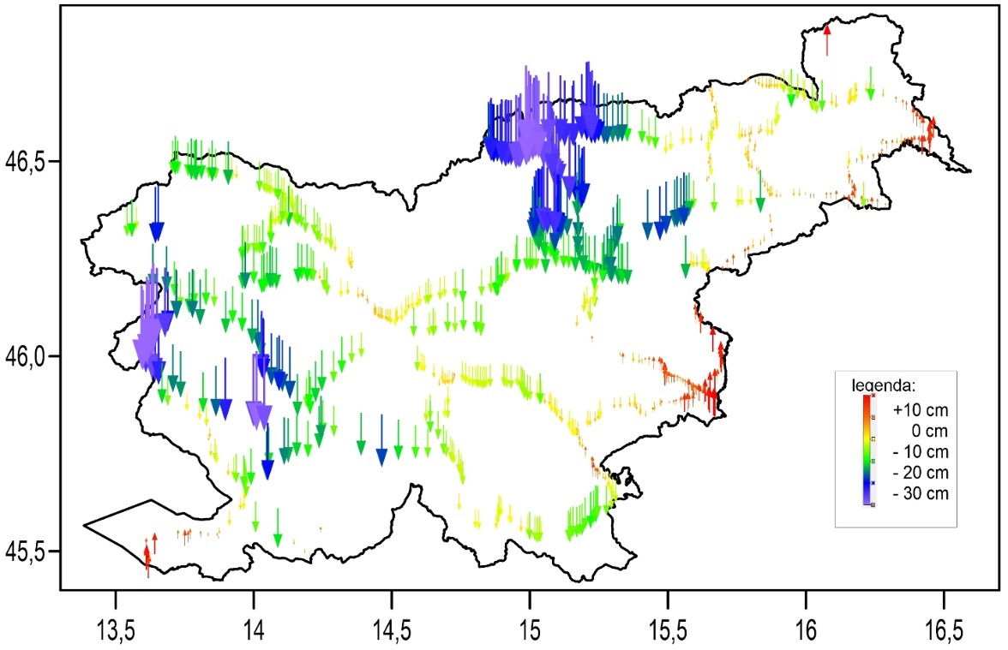

***Figure 1:*** *An example of captioning a figure. Figures shall be numbered from 1 onwards, independently of the tables – between the number and title use colon and space. ( Times, 10, left; the width of a figure is recommended to be 66 mm or 137 mm)*

…

**Literature and references:** (Times, 10, bold, left)

Ambrožič, M. (2000). Testiranje razdaljemera elektronskega tahimetra Leica TCR 307 pri merjenju dolžin brez uporabe reflektorja. Diploma thesis. Ljubljana: University of Ljubljana. Faculty of Civil and Geodetic Engineering.

Berry, J. K. (2007). Beyond Mapping III: Procedures and applications in GIS modeling. <http://www.innovativegis.com/basis/BeyondMappingSeries/BeyondMapping_III/Default.htm>, accessed 30. 6. 2019.

Joeckl, R., Stober, M. (1989). Elektronische Entfernungs- und Richtungsmessung. Stuttgart: Verlag Konrad Wittwer GmbH.

Triglav Čekada, M. (2010). Zračno lasersko skeniranje in nepremičninske evidence. Geodetski vestnik, 54 (2), 181–194. DOI: [https://doi.org/10.15292/geodetski-vestnik.2010.02.181-194](https://doi.org/10.15292/geodetski-vestnik.2010.02.181-194%20)

Vrabec., M., Fodor, L. (2006). Late Cenozoic Tectonic of Slovenia: Structural styles at the Norteastern Corner of the Adriatic Microplate. In N. Pinter (Ed.), G. Grenerczy (Ed.), J. Weber (Ed.), S. Stein, D. Medak, The Adria Microplate: GPS Geodesy, Tectonic and Hazards. NATO Science Series, IV, Earth and Environmental Sciences (pp. 151–168). Springer. DOI: [https://doi.org/10.1007/1-4020-4235-3_10](https://doi.org/10.1007/1-4020-4235-3_10%20)